**Create campaign flow (Campaign details and Choose games)**

**Acceptance Criteria:**  
**1. Mandatory Fields:**  
   - The user must provide a **detailed name** and a **budget** when creating a campaign.  
   - All values entered are reflected in the **sidebar** accordingly.

User receives following error messages if left blank:

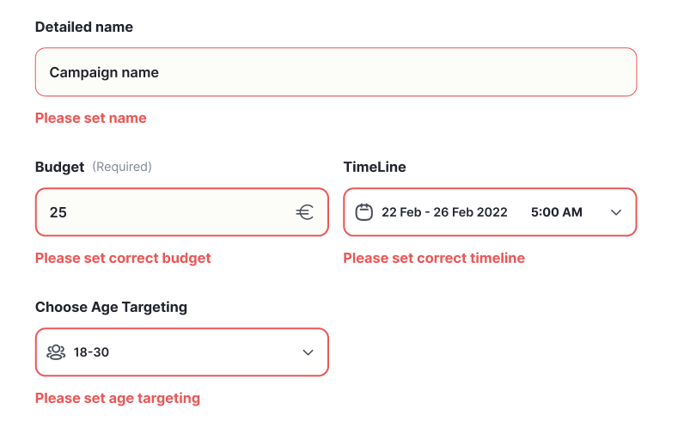

Age targeting: User can either choose 18- or 18+; the rest are disabled to choose.  
  
**2. Timeline Restrictions:**  
   - The user is restricted from selecting any **past dates** for the campaign timeline.

*Timeline design:*

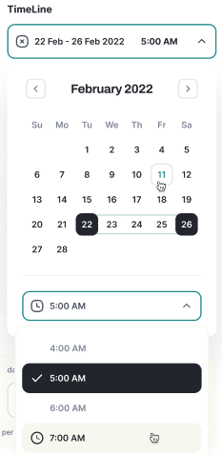  
  
**3. Sidebar Access:**  
   - The sidebar is **locked** (not accessible) until it turns **green**, which indicates that the necessary stages have been completed. The user cannot open the sidebar unless this condition is met.  
  
**4. Campaign Type Selection:**  
   - After completing the campaign details, the user is prompted to choose the **campaign type**, which can either be:  
     - **General**  
     - **Special**  
   - The user can click on a **"See More"** button to view each game listed in game groups. But when user clicks on see more for individual games game details are displayed correctly:

1. Game image/name
2. Game description pulled from platform
3. Statistics

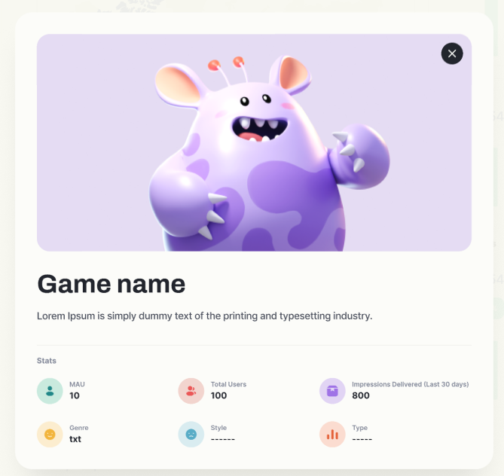   
  
**5. Game Selection:**  
   - On the "Choose Games" page, the **Genre**, **Type**, and **Name** filters should function correctly.  
   - The user can choose games one by one from a list of game groups.